## Reports Menu/Pseudoephedrine/Store Summary:

Request:

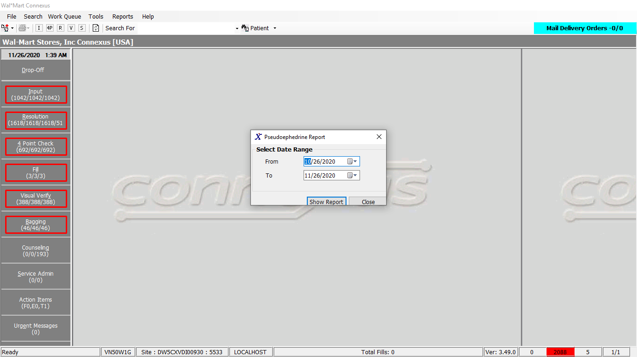

Response:

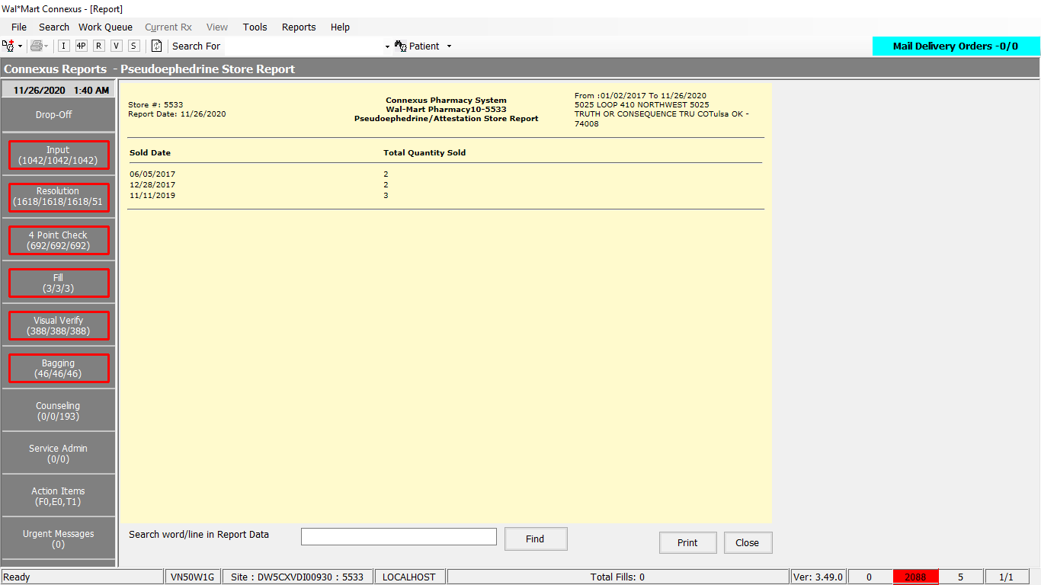

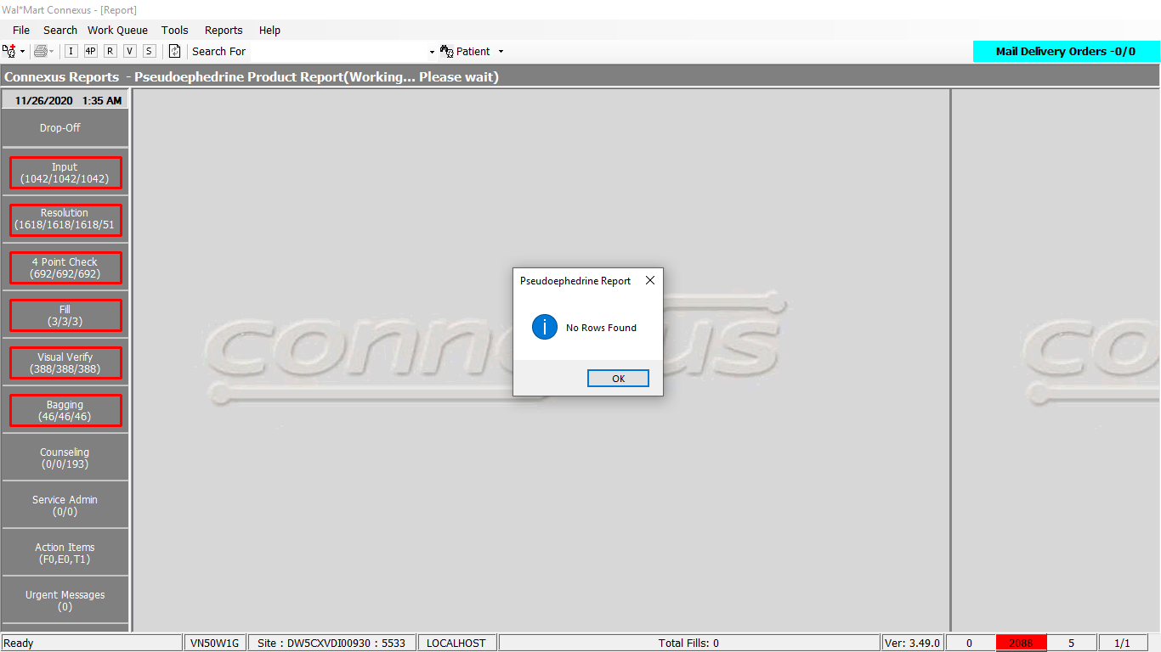

Queries:

Public Const GetRestrictedTransByStore As String = _

"SELECT date(rt.txn_ts) txn_ts, sum(rti.item_each_qty) sum_item_each_qty" _

& " FROM rstr_txn rt, rstr_txn_item rti, pharmacy_offering:pharmacy_item pi" _

& " WHERE rt.rstr_txn_id = rti.rstr_txn_id" _

& " AND rti.mds_fam_id = pi.mds_fam_id" _

& " AND date(rt.txn_ts) >= ? AND date(rt.txn_ts) <= ?" _

& " group by 1 order by 1 ;"

DAL:

Public Function GetRestrictedTransByStore(ByVal siteId As Integer, ByVal startDate As DateTime, ByVal endDate As DateTime) As List(Of RestrictedTransactionBE) Implements ITrackerDAL.GetRestrictedTransByStore

Using (New Tracer(ConnexusCommonConstants.ConnexusTracer))

'Add parameters to ParamList

Dim paramList As New List(Of DbParameter)

paramList.AddParameter(DbType.String, String.Format(CultureInfo.InvariantCulture, "{0:MM/dd/yyyy}", startDate))

paramList.AddParameter(DbType.String, String.Format(CultureInfo.InvariantCulture, "{0:MM/dd/yyyy}", endDate))

Dim listRestrictedTransByStoreBE As New List(Of RestrictedTransactionBE)

'Execute Query

Using dr As IDataReader = ExecuteReader(DatabaseEnum.rx21c, siteId, TrackerQueries.GetRestrictedTransByStore, paramList)

While dr.Read

Dim restrictedTransactionBE As New RestrictedTransactionBE

restrictedTransactionBE.TxnTs = dr.GetValueOrDefault(Of Date)("txn_ts")

restrictedTransactionBE.ItemEachQty = Convert.ToInt16(dr.GetValueOrDefault(Of Decimal)("sum_item_each_qty"), CultureInfo.InvariantCulture)

listRestrictedTransByStoreBE.Add(restrictedTransactionBE)

End While

End Using

If listRestrictedTransByStoreBE.Count = 0 Then

listRestrictedTransByStoreBE = Nothing

End If

Return listRestrictedTransByStoreBE

End Using

End Function